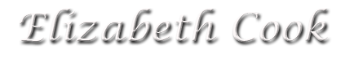
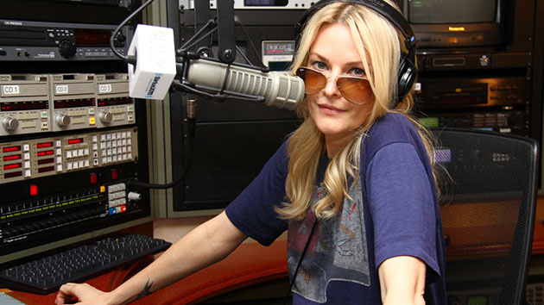
Elizabeth Cook (born July 17, 1972 in Wildwood, Florida) is an American country music singer. She made her debut on the Grand Ole Opry on March 17, 2000. Cook, "the daughter of a hillbilly singer married to a moonshiner who played his upright bass while in a prison band," was "virtually unknown to the pop masses" before she made a debut appearance on the Late Show With David Letterman in June 2012. The New York Times called her "a sharp and surprising country singer" and an "idiosyncratic traditionalist."
The youngest of 11, Cook was born in Wildwood, Florida. Her mother Joyce played mandolin and guitar and performed on radio and local television in her younger years. Her father Thomas also played string instruments. He honed his skills playing upright bass in the prison band while serving time for running moonshine. Also while serving time at the Atlanta Federal Penitentiary for the crime, he learned the welding trade to which Elizabeth paid tribute in the title of her 2010 album. After her father was released, he and Joyce began playing in local country bands together. Elizabeth was on stage with them at age four, singing such inappropriate songs as 'I'm Having Daydreams About Night Things'. At the age of nine, she had her own band.

Cook graduated from Georgia Southern University in 1996 with dual degrees in Accounting and Computer Information Systems. In 2000, she independently released The Blue Album; she made her major label debut in 2002 with Hey Y'All. But following a corporate re-structuring that left the album virtually abandoned and stagnant on sales, Elizabeth fought back with her 2004 independent release This Side Of The Moon, which received positive reviews from The New York Times and No Depression. Her album Balls was released May 2007. It has been her most successful album to date, thanks to glowing press reviews and significant video play for the song "Sometimes It Takes Balls To Be A Woman." Her 2010 album Welder features appearances by an all-star roster of guests including Dwight Yoakam, Crowell and Buddy Miller. Two songs on the album featured in an NPR report at the time of its release were "El Camino" and "Heroin Addict Sister."

Through it all, Elizabeth maintained a full touring schedule, playing in America, as well as South Korea, Japan, Norway, Sweden, Poland France and the UK, the last of these including appearances at the Cambridge Folk Festival, the Maverick Festival and the Borderline in London. She has continued appearing on stage at the Grand Ole Opry - indeed, she has appeared over 300 times and yet is still a "non-member".

She toured the UK in support of her Welder LP performing 18 dates with her husband Tim Carroll and her upright bass player Bones Hillman, formerly of Midnight Oil, who had relocated to Nashville, Tennessee after hearing nothing out of Midnight Oil for a year.

Cook was invited by the Atlanta Braves to sing the national anthem before their 2011 home opener on April 8, 2011.

In June 2012 Cook appeared with Jason Isbell on the Late Show with David Letterman. American Songwriter notes that they sang covers of Townes Van Zandt's "Pancho and Lefty" and "Tecumseh Valley." On March 14, 2013, she again appeared on the Late Show with David Letterman, this time having a sit down interview with Dave before performing "If I Had My Way," written by blues/gospel singer Blind Willie Johnson. On June 2, 2014, she again appeared on the Late Show with David Letterman, performing "Pale Blue Eyes," written by Lou Reed.
Cook hosts the morning radio show "Elizabeth Cook's Apron Strings" on the Sirius XM radio station Outlaw Country on Channel 60. The show airs weekdays from 6:00 AM until 10:00 AM (Eastern Time). The show format is a mix of Americana, Outlaw, and Alt Country. As a radio presenter, Cook has been nominated for 2 Ameripolitan Music Awards.

